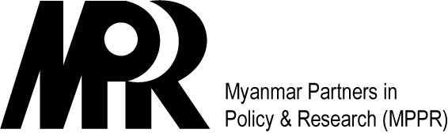

Family Planning in Myanmar

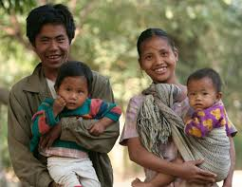
MYANMAR’S FP2020 COMMITMENT
Myanmar's recent transition to more open society and governing holds many opportunities to improve quality of life including progress in health indicators such as increased life expectancy and decreased maternal mortality. In 2013, the Government of Myanmar joined many countries with a pledge to FP2020 that includes commitments to address policy, financing, service delivery and socio-cultural barriers for men and women to access family planning information and services. Following the FP2020 agenda, the Government committed to increase the Contraceptive Prevalence Rate (CPR) from the current 41% to 50% by 2015 and to 60% by 2020, and to reduce the unmet need to below 10% by 2015. In addition, the Government planned to increase the health budget for contraceptive services to cover 30 million eligible couples in need by 2020.

Strong political and financial commitments are imperative to meeting the goals of FP2020. Myanmar has made commitments to increase the budget for family planning in order to cover the needs of nearly 30 million couples by 2020. The Ministry of Health and Sports is committed to working toward increasing the resources allocated to family planning in the states and regions’ budgets.

With the increased budget and more decentralized planning, the Government of Myanmar plans to reach FP2020 goals by implementing policies that address regional disparities, resulting in reduced inequity between urban and rural, and rich and poor populations.

FAMILY PLANNING IN THE CONTEXT OF DEVELOPMENT

Family Planning is the Most Cost-Effective Investment for Health, Education, and Development
The role of family planning (FP) is critical to the well-being of families and the nation as a whole.
- FP reduces public spending: FP saves public sector spending for other investments and yields great returns on investment by preventing unintended pregnancies. Each dollar spent on FP can save governments up to US$6 on health, housing, water, and other public services, and every US$1 invested in FP yields $2-$13, relieving pressure on social services and scarce national resources.

- Reducing infant mortality and improving maternal health with FP: the research evidence is clear. Access to FP contributes to better maternal, newborn and child health. If unmet need for FP were met globally, this could result in a 70% decline in unintended pregnancies, 74% decline in unsafe abortion, 33% decline in maternal deaths, and 23% reduction in newborn deaths.

- FP helps eradicate extreme poverty and hunger: the use of FP contributes to lower fertility rates that lead to slower population growth, which positively impacts economic growth, female labor force participation and income distribution.

- FP increases access to education: Access to FP would lead to the delay of early pregnancy, staying in school longer, and completing the necessary education to take advantage of greater economic opportunities to reduce poverty. In turn, those who receive higher education tend to marry later, have fewer and healthier children, and participate in greater numbers in the labor force. Likewise, educated women are less likely to die in pregnancy or childbirth and more likely to send their own children to school.

- Opportunities for demographic dividend: Myanmar can capitalize on the demographic dividend as many of their SE Asian neighbors. With more young people entering working age, these Myanmar citizens have the potential to contribute to economic growth and stability if education and employment opportunities are made available. The “East Asian miracle” is an example of countries reaping the benefits of a “youth bulge” in creating a robust labor force that contributed to a stronger tax base and economic growth. Myanmar’s young population under age 15 accounts for a quarter of its population. If the government invests in adolescent sexual and reproductive health (ASRH) information and services, with an emphasis also on increased access to education and economic opportunities, Myanmar has the potential to capitalize on this demographic dividend.

WHAT YOU CAN DO
In order to reap the benefits of family planning as a nation, we need commitments from individuals like you to address the unmet need for family planning. Actions you can take may include:
- Ensuring continued political commitment to family planning through awareness raising
- Creating enabling policies and guidelines to improve contraceptive service delivery
- Allocating increased financial resources for family planning
- Prioritizing contraceptive commodities in budget allocations
- Addressing young people’s need for sexual and reproductive health services
- Increasing choices of contraceptive methods and products
- Collaborating across ministries and partnering with private sector partners to accelerate impact
- Strengthening data monitoring and reporting systems
- Promoting gender-sensitive, rights-based programming and high quality of care

USAID, Achieving the MDGs: The Contribution of fulfilling the unmet need for family planning. Washington DC: Futures Group International, 2006.
Singh S, Darroch JE and Ashford LS, Adding It Up: The Costs and Benefits of Investing in Sexual and Reproductive Health—2014, New York: Guttmacher Institute, 2014.

